OptiCrop – Smart Agricultural Production Optimization Engine

Project Description:
The project Smart Agricultural Production Optimization Engine” aims to develop an advanced software system that utilizes data-driven insights to optimize agricultural
production for different crops. By integrating key environmental factors such as Nitrogen (N), Phosphorous (P), Potassium (K) levels, soil temperature, humidity, pH, rainfall, and crop types, OptiCrop seeks to provide intelligent recommendations to farmers for maximizing yields and resource efficiency. The knowledge and insights gained through the OptiCrop project can be utilized by agricultural researchers, policymakers, and stakeholders to advance the understanding of crop-environment interactions and inform the development of evidence-based agricultural strategies. The OptiCrop project revolutionizes agricultural practices by providing farmers with a smart production optimization engine. By integrating key environmental factors and crop-specific recommendations, OptiCrop enables farmers to achieve optimal yields, improve resource efficiency, and contribute to sustainable agricultural practices.
Scenarios
Scenario 1: Smart Crop Recommendation for Farmers
A farmer enters soil and environmental details such as Nitrogen (N), Phosphorous (P), Potassium (K), temperature, humidity, pH level, and rainfall. The system analyzes the data and recommends the most suitable crop for maximum yield and better farming efficiency.
Scenario 2: Crop Suitability and Environmental Assessment
A user wants to understand whether the current soil and climate conditions are suitable for a particular crop. The application evaluates the input parameters and provides insights about crop compatibility, environmental suitability, and productivity potential.
Scenario 3: Agricultural Research and Policy Planning
An agricultural researcher or policymaker uses the system to analyze crop-environment relationships and identify patterns in agricultural production. The platform helps in making data-driven decisions for sustainable farming strategies and resource optimization.

Technical Architecture:
User
↓
Web Interface (HTML, CSS, JavaScript)
↓
Flask Backend (Python)
↓
Machine Learning Model (Scikit-learn)
↓
Crop Prediction Engine
↓
Recommended Crop Result

Description:
The OptiCrop system follows a three-layer architecture consisting of the User Interface Layer, Application Layer, and Machine Learning Layer. The frontend is developed using HTML, CSS, and JavaScript, allowing users to enter agricultural parameters such as Nitrogen, Phosphorus, Potassium, Temperature, Humidity, pH, and Rainfall. The Flask backend processes the user input, validates the data, and sends it to the trained Machine Learning model.
The Machine Learning model, developed using Python and Scikit-learn, analyzes the input parameters and predicts the most suitable crop for cultivation. The prediction result is then returned to the Flask application and displayed to the user through the web interface. This architecture provides an efficient, user-friendly, and intelligent crop recommendation system that assists farmers in making data-driven agricultural decisions and improving crop productivity.

Pre-requisites:
- Python
- Flask
- Pandas
- NumPy
- Scikit-learn
- HTML
- CSS
- JavaScript
- Git and GitHub

Project Workflow:
Epic 1: Define Problem and Understanding
Story 1: Identify and define the agricultural problem that the crop recommendation system aims to solve.
Story 2: Gather and analyze business requirements to understand project objectives and expected outcomes.
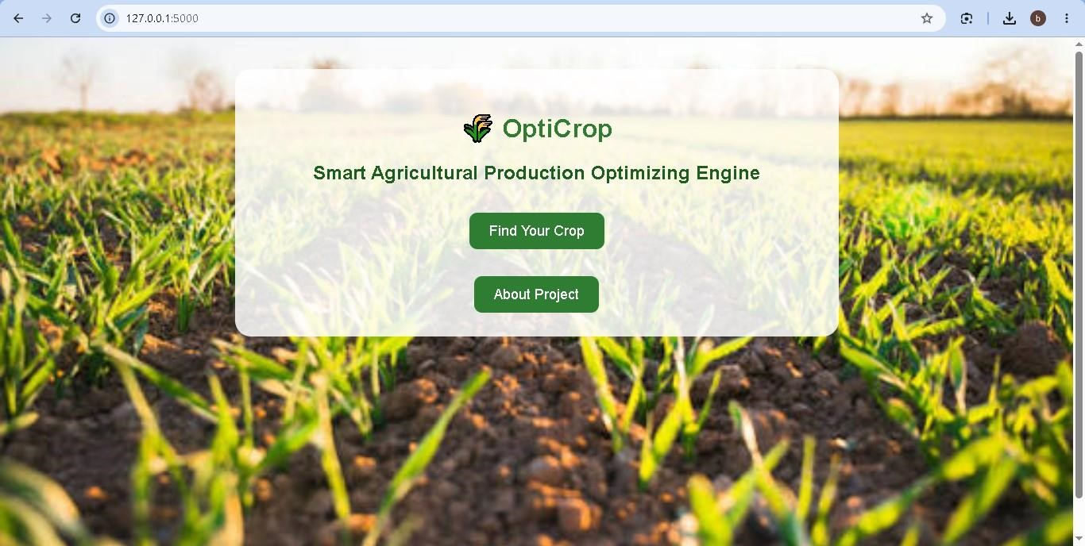
Story 3: Conduct a literature survey to study existing crop recommendation techniques and machine learning approaches.
Story 4: Analyze the social and business impact of implementing an AI-driven crop recommendation solution.
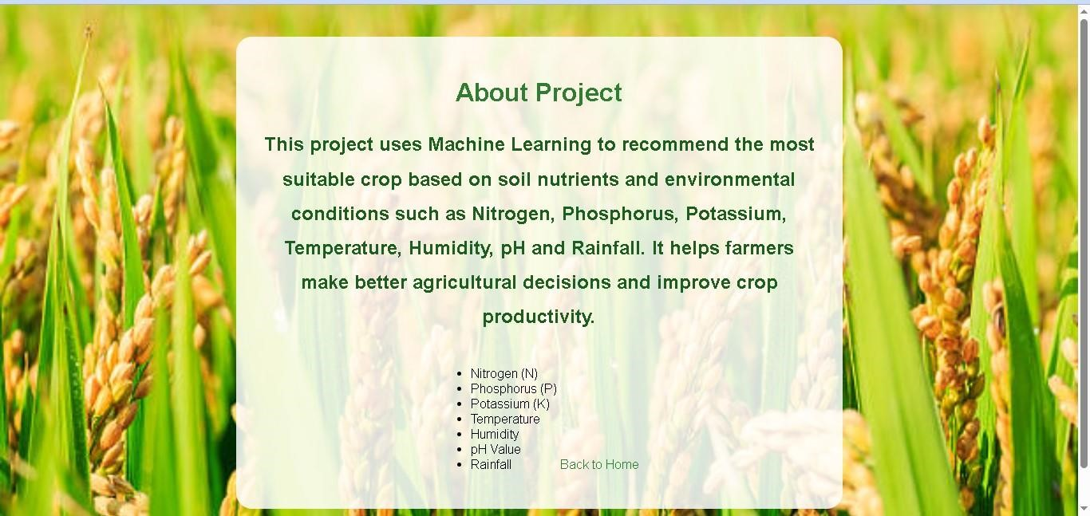
Epic 2: Data Collection and Analysis
Story 1: Download and collect the agricultural dataset from reliable sources.
Story 2: Import the required Python libraries for data analysis, visualization, and machine learning.
Story 3: Read and explore the dataset to understand its structure, features, and target variables.
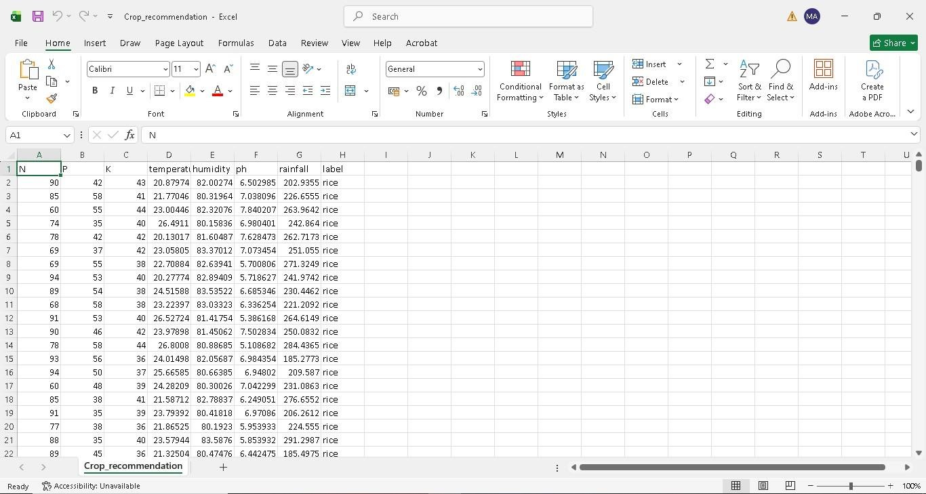
Story 4: Perform univariate analysis to examine the distribution and characteristics of individual features.
Story 5: Conduct bivariate analysis to identify relationships between agricultural parameters and crop suitability.
Story 6: Perform multivariate analysis to discover patterns and interactions among multiple variables.
Epic 3: Data Pre-Processing
Story 1: Check for null values and handle missing data to improve dataset quality.
Story 2: Detect and treat outliers that may affect model performance.
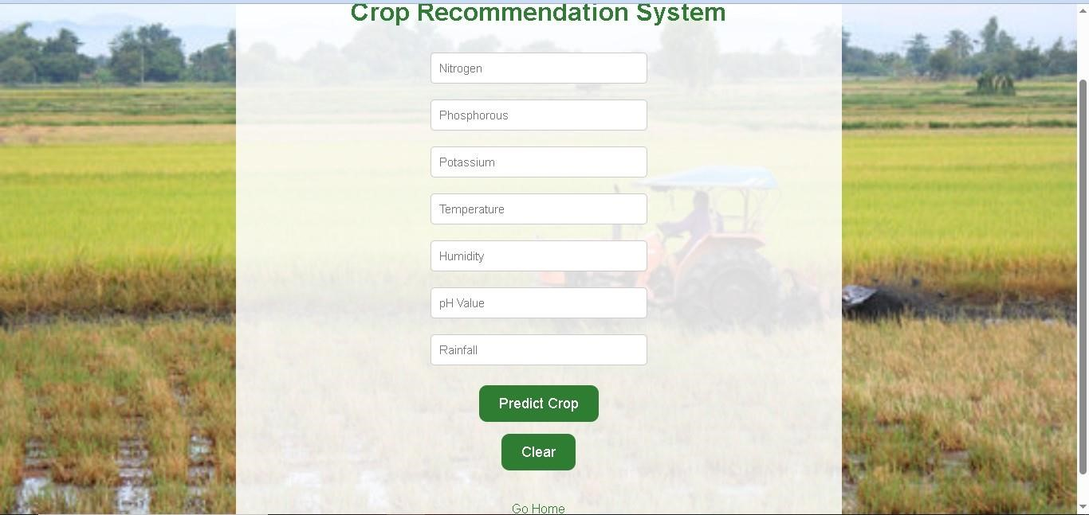
Story 3: Extract seasonal crop information and prepare relevant features for analysis.
Story 4: Split the dataset into training and testing sets for model development and evaluation.
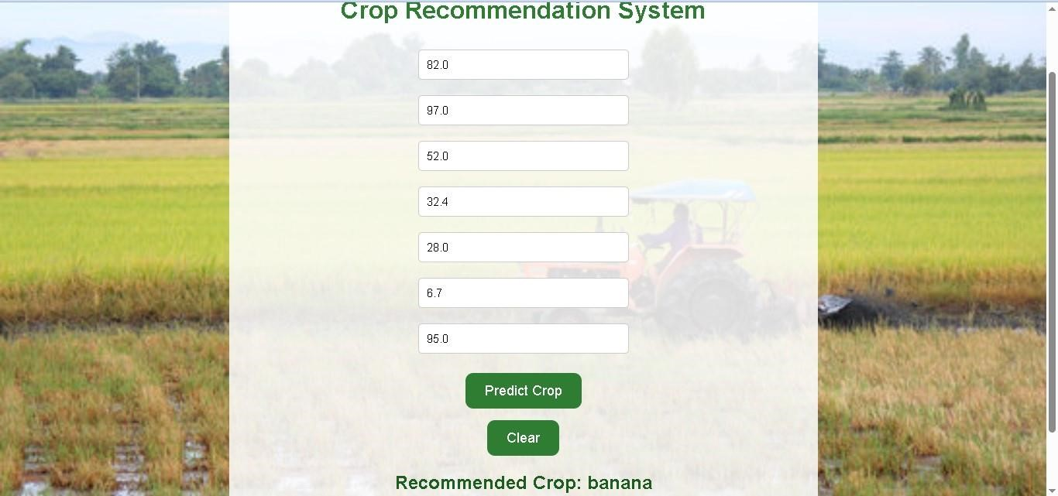
Epic 4: Model Building
Story 1: Apply K-Means Clustering to identify patterns and group similar agricultural conditions.
Story 2: Train a Logistic Regression model to predict suitable crops based on environmental parameters.

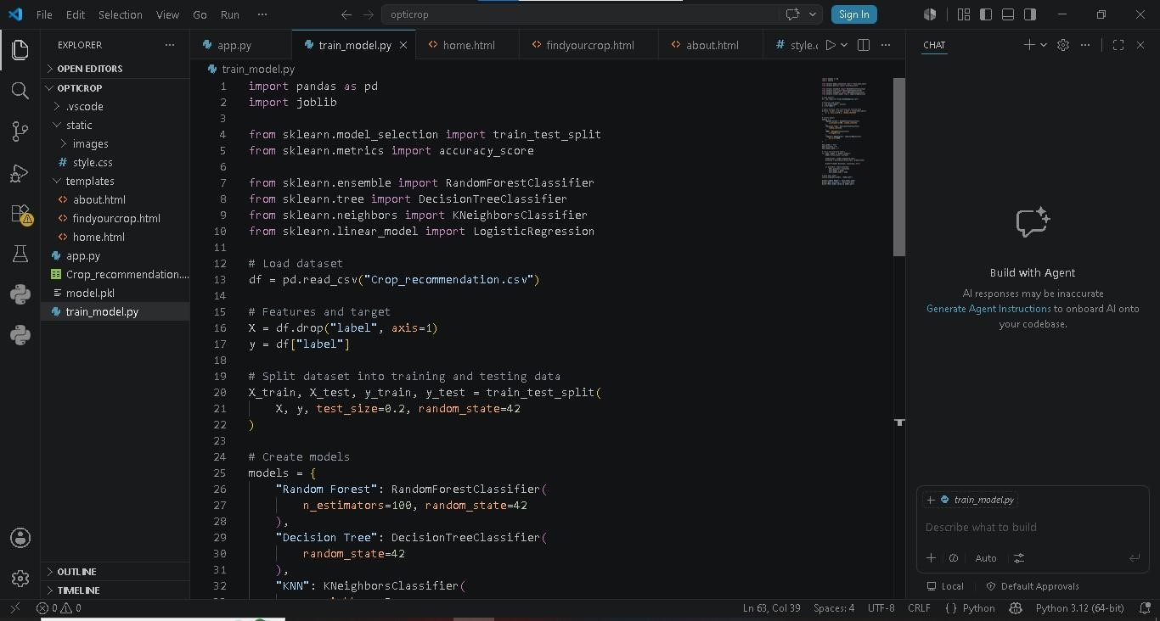
Story 3: Evaluate model performance using appropriate metrics and compare results.
Story 4: Save the best-performing model for deployment and generate crop predictions based on user-provided inputs.
Epic 5: Application Building
Story 1: Design and develop HTML pages to create an interactive and userfriendly interface.
Story 2: Build the Python backend code and integrate it with the trained machine learning model.
Story 3: Run, test, and validate the application to ensure accurate crop recommendations and smooth functionality.
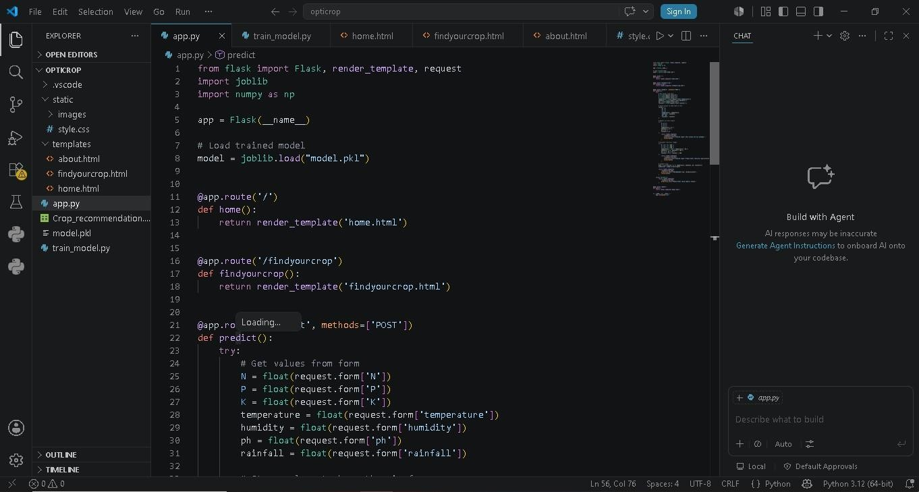
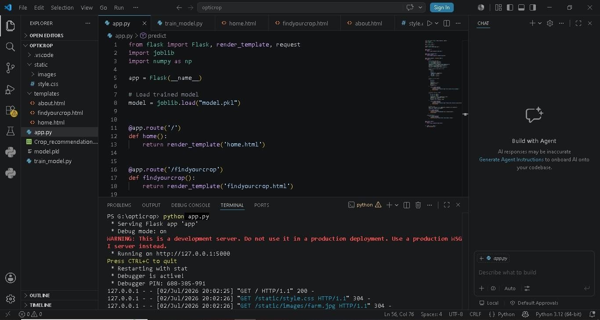

Exploring the Website’s Web Pages:
Home Page:

Description:
The Home Page is the main entry point of the OptiCrop – Smart Agricultural Production Optimization Engine. It provides an attractive and user-friendly interface with an agricultural background image and introduces the project to users. The page contains two main buttons: Find Your Crop and About Project. The "Find Your Crop" button redirects users to the crop prediction page, while the "About Project" button provides information about the project and its objectives. The home page is designed to give users easy navigation and a professional look.
Input Section:

Description:
The Find Your Crop page is the core functionality of the project. This page allows users to enter important agricultural parameters such as:
- Nitrogen (N)
- Phosphorus (P)
- Potassium (K)
- Temperature
- Humidity
- pH Value
- Rainfall
After entering these values, the user clicks the Predict Crop button. The Flask backend sends the data to the trained Machine Learning model, which analyzes the input and predicts the most suitable crop for cultivation. The predicted crop is then displayed to the user. A Clear button is also provided to reset all input fields.

Result Section:

Description:
The OptiCrop – Smart Agricultural Production Optimization Engine was successfully developed and tested. The system accepts agricultural input parameters such as Nitrogen, Phosphorus, Potassium, Temperature, Humidity, pH, and Rainfall and predicts the most suitable crop using a trained Machine Learning model.
The web application provides accurate and quick crop recommendations through a simple and user-friendly interface. The prediction results help farmers make informed agricultural decisions, improve crop productivity, and select crops that are suitable for their soil and environmental conditions.
The project successfully demonstrates the practical application of Machine Learning in Agriculture by integrating a Flask web application with a crop prediction model.
About Page:

Description:
The About Project page provides detailed information about the purpose and working of the AI-ML OptiCrop system. It explains that the project uses Machine Learning techniques to recommend the most suitable crop based on soil nutrients and environmental conditions. The page describes the input parameters used by the system, including Nitrogen, Phosphorus, Potassium, Temperature, Humidity, pH, and Rainfall. It also highlights the benefits of the system, such as helping farmers make better agricultural decisions and improving crop productivity.
Conclusion:
OptiCrop is an advanced Machine Learning-powered smart agricultural recommendation system designed to support modern, data-driven farming practices by providing accurate and intelligent crop prediction solutions. The system analyzes multiple critical environmental and soil-related parameters including nitrogen, phosphorus, and potassium (NPK) soil nutrient levels, temperature, humidity, soil pH, and rainfall patterns to determine the most suitable crop for cultivation under specific conditions. By combining agricultural science with artificial intelligence, OptiCrop aims to reduce uncertainty in farming decisions and promote efficient, sustainable agricultural production.
The project leverages multiple Machine Learning algorithms such as K-Nearest Neighbors (KNN), K-Means Clustering, and Logistic Regression to perform crop classification and recommendation tasks. Each algorithm contributes uniquely to the prediction process: KNN identifies similar environmental conditions based on historical agricultural data, K-Means helps in grouping and analyzing soil and climate patterns, while Logistic Regression provides accurate classification of the most appropriate crop category. The use of multiple models allows comparative analysis and improves the reliability and robustness of predictions, ensuring better recommendation accuracy across varying agricultural conditions.

